Chapter 9, Solution 44.

Calculate i(t) in the circuit of Fig. 9.51.

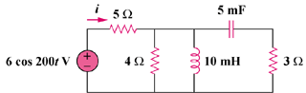

Figure 9.51
For Prob. 9.44.

Solution

Thus,
i(t) = 960cos(200t – 7.956) mA

